Tips to Join TeamASHT for the 7th Annual AHTF Virtual Run/Walk

1. Visit this page and select the red “Join this Team” button

2. Select the number of tickets
a. The checkout button will be highlighted once total cost is calculated (e.g. $31.00 + fees $2.59)
b. Fill in all of your contact information (e.g. name, email, etc.)
c. If you have used eventbrite.com in the past, use your previous login for quicker data entry.
d. Please type TeamASHT under “donating in support of a participant or team”
e. Click the “Checkout” button to complete your order

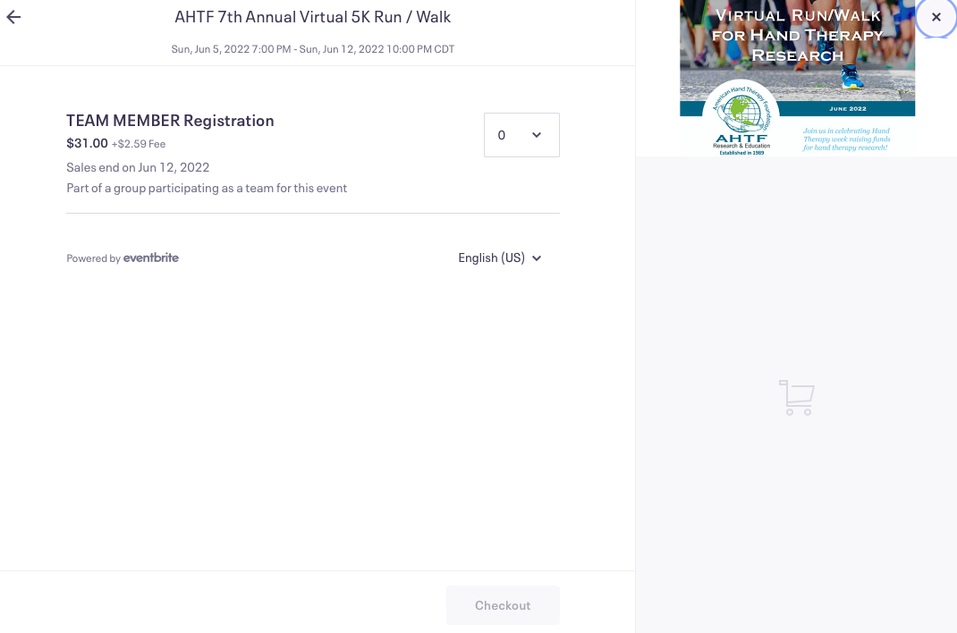

Thank you for your participation!

