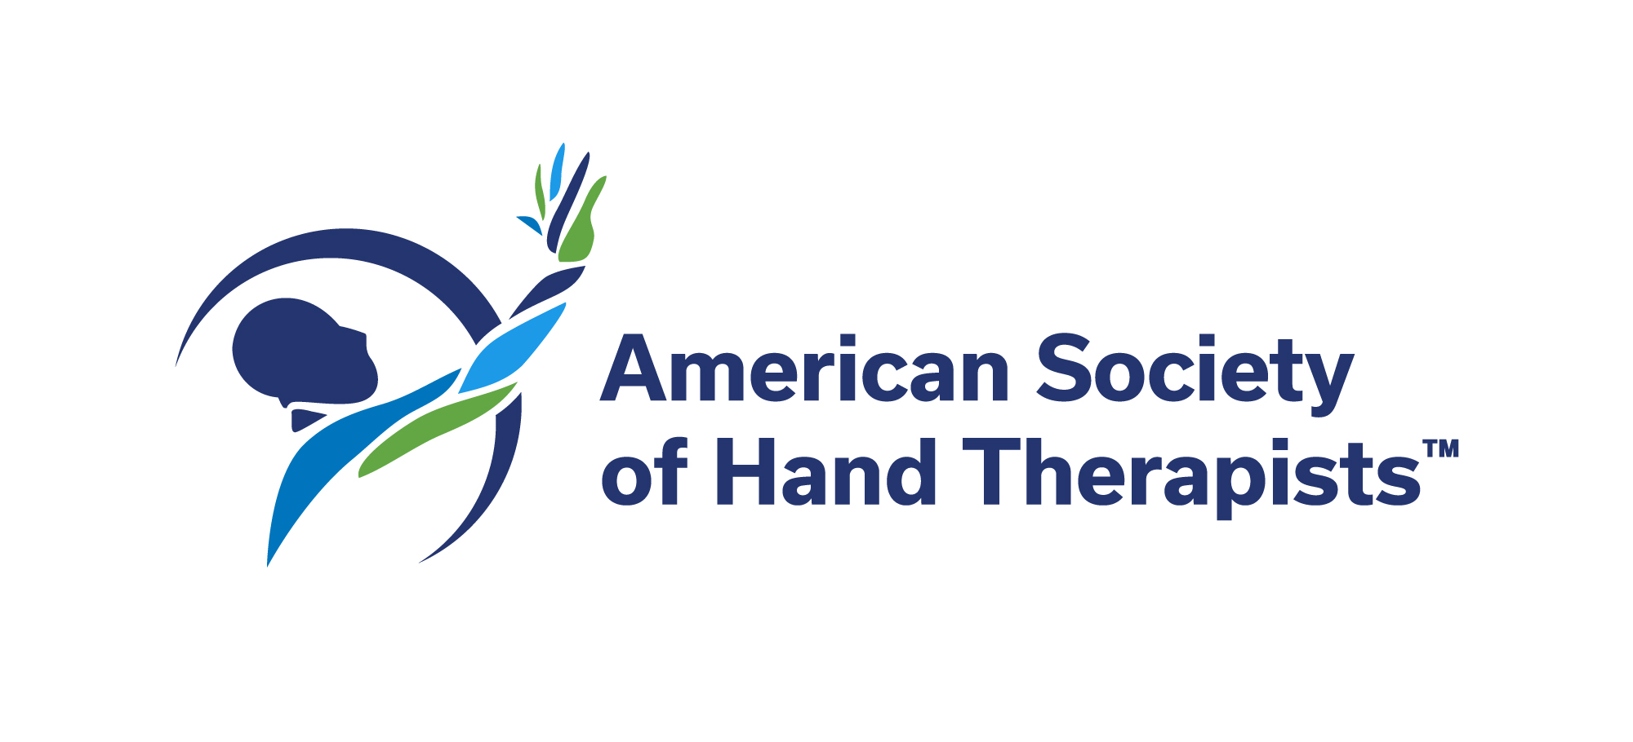

AAHS/ASHT International Reverse Therapy Fellowship

The American Association for Hand Surgery (AAHS) in partnership with the American Society of Hand Therapists (ASHT) established the International Reverse Therapy Fellowship in 2019. The program sponsors an international hand therapist’s visits with AAHS and ASHT member therapists at their institutions with the aim to provide expert education so that the Fellow may return home to improve therapy education and patient care in their country.

The selected International Reverse Therapy Fellow will receive $10,000 from AAHS to be used towards a 4-week visit to North America to travel to the institutions of and train with two AAHS and ASHT member therapists. The 4-week period will allow for travel and 1 week at each host institution.

Fellowship Eligibility

- Applicants must be therapists and have a minimum of 3 clinical practice experience.
- Applicants must have completed his or her therapist training and be early in his or her hand therapy career.
- Ideal applicants have opportunities to teach other therapists and/or students.
- Applicants must be from a developing nation.
- Applicants must have the ability to communicate in English.

Conditions of Fellowship

- The recipient will visit two AAHS/ASHT therapist member institutions over a 4-week period between October and November.
- The recipient must submit a complete itinerary prior to travel to receive funds. Funds will be disbursed incrementally to the recipient.
- AAHS is required by the Internal Revenue Service (IRS) to document disbursement of funds, as well as to maintain annual reports on the funded programs. For reimbursement the recipient must provide a summary of expenses including original receipts.
- The recipient may be able to use any leftover funds to travel to the AAHS Annual Meeting the following year to present a summary of his/her experience.
- The recipient will be asked to document his or her experience with HIPAA appropriate photos and videos which may be used by the AAHS for promotion of the International Reverse Therapy Fellowship program.
- Following the completion of the Fellowship, the recipient will be asked to provide a video summary of his or her experience which may be used by the AAHS for promotion of the International Reverse Therapy Fellowship program.
- The recipient will also provide a written report one year from the conclusion of the Fellowship on how the experience has affected his/her practice and local care.
- •The Fellowship recipient may be asked to complete a confidentiality form, consent form, and/or submit medical records to host institutions based on host institution policy.

Completed applications should be forwarded to contact@handsurgery.org November 1, 2022.

AAHS/ASHT International Reverse Therapy Fellowship

Personal Information

Name:

Age:

Mailing address

Street:

City:

State, Province, Local:

Country:

Email address:

Mobile phone:

Office phone:

Fax:

Current Professional Status

Professional Title:

Specialty (e.g. Physical Therapy, Occupational Therapy, Certified Hand Therapist):

Location:

Name of Institution or Clinic:

City:

State, Province, or Local:

Country:

Years at Current Position:

Supervisor or Advisor at Current Institution or Clinic:

Education

If you need to list more than one in any category, please list primary below and include others as an attachment(s).

Undergraduate

Name of Institution:

Location:

Dates attended:

Graduate

Name of Institution:

Location:

Dates attended:

Medical School (if applicable)

Name of Institution:

Location:

Dates attended:

Therapy Training (since completing basic education)

If you need to list more than one in any category, please list primary below and include others as an attachment(s).

Name of Institution:

Supervisor, advisor or mentor:

Address:

City and State, Province, or Local):

Country:

Dates of service:

Name of institution:

Supervisor or advisor or mentor:

Address:

City and State, Province, or Local):

Country:

Dates of service:

Clinical Responsibilities

Please provide a description of your current clinical practice including type of patients, contacts with colleagues and trainees, students and other health care providers.

Teaching Responsibilities

If your practice includes education, please provide a brief description of your responsibilities and interactions including, trainees, students or other healthcare professionals)

Personal Goals to Achieve during this Fellowship

Please briefly description professional goals you will aim to achieve during this Fellowship (e.g., increase knowledge of various conditions, learn new techniques, develop connections with established therapists and hand care professionals, etc.).

Career Goals

Please briefly describe your professional goals for future clinical care in hand therapy, teaching, possible research or other academic activities, leadership positions in teaching programs or hospital administration.)

Support from Members and Mentors

We invite you to submit letters from your mentors and/or AAHS and ASHT members to support your application. This is optional and not a required component of this application. If you have a mentor or AAHS or ASHT member planning to provide a letter of support, please indicate their information below.

Name and Title:

Location:

Relationship (e.g. teacher, local doctor, educational activities):

Name and Title:

Location:

Relationship (e.g. teacher, local doctor, educational activities):

Health Statement

MMR (Measles, Mumps, Rubella) Vaccines DOB:

(2) MMR Vaccines /
Date Date
OR

Rubella (German measles)

(1) Vaccine or (1) Positive Titer
Date
Rubeola (Measles)

(2)Vaccines or (1) Positive Titer /
Date Date
Mumps

(2) Vaccines or (1) Positive Titer /
Date Date

Varicella (Chicken Pox)

(2) Vaccines or (1) Positive Titer /
Date Date

Hepatitis B Vaccine

(3) Vaccines / /
Date Date Date

OR

Titer: Hep B sAB
Date – Positive Date - Negative
OR

Declination: I do not wish to receive the Hepatitis B Vaccine (Sign Below)

___________________________________________________
Academic Visitor Signature of declination

Tuberculosis Screening

Mantoux (PPD): Negative /mm Date
Positive /mm Date

If positive: Chest X-Ray Date Read by: Contact #:

Influenza (flu) Shot

(1) Vaccine
Date

SIGNATURE OF ACADEMIC VISITOR: _________________________________DATE:

